


Back Promotion Checker


Document Control Information
Document Information
Document Name | Back Promotion Checker Document
Project Name | Humana Salesforce DevOps
Client | Humana
Document Author | Rama Puvvula
Document Version | 1.0
Document Status | Pending
Date Released | 6/16/2023
Document Edit History
Version | Date | Additions/Modifications | Prepared/Revised by
Document Review/Approval History
Date | Name | Organization/Title | Comments

Table of Contents
1. Back Promotion Checker Document 5

Introduction

This document will helps us step by step process on Copado best practices on dealing with pending Back Promotions with guided screens for the workflow.
Back Promotion Enforcer/Checker extension Overview :
This solution allows you to enforce best practices and help customers get into the discipline of back promotion continuously.

It is a good practice to prevent promotions to be completed if the target environment is not in sync. If there are pending back promotions in the destination, the promotion will not be done and an error message will be displayed.

Implemented for classic and 2nd gen pipelines.

Configuration
E3 Copado team is responsible for the Back promotion checker configuration. We also configured the quality gate to pass custom conditions for the extension to be active. We have a custom flow created and is active to count number of Back promotions.

Quality gate conditions:
E3 Copado team will handle the custom conditions based on the respective team. Take a look below to see which custom conditions to pass.
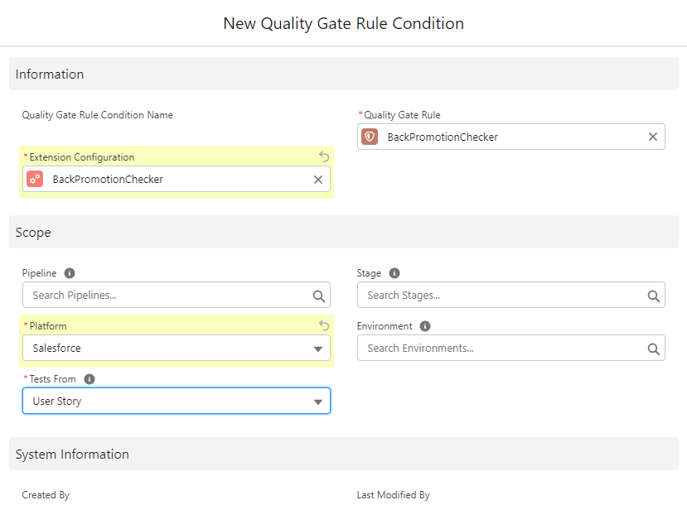
- You can enable/disable the quality gate to a respective pipeline.
- You can select which env should be enabled for the Back Promotion checker.
Note : We are enabling this back promotion checker on the User Story level.

Use Cases:
Below screenshot shows one of our test pipeline where back promotion checker is enabled for all the envs

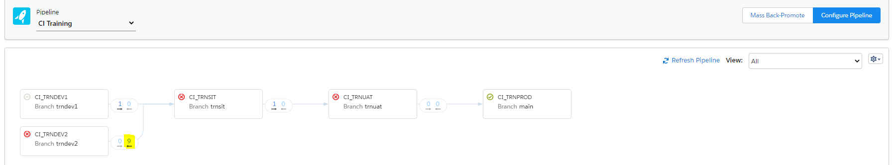
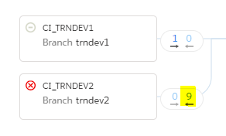

You can see there are 9 pending back promotions from UAT to DEV2 in the above screenshot. Which indicates DEV1 and DEV2 are not in sync.
Now take a User Story created in DEV2 and all checks are passed. Now when you try to deploy from DEV2 to SIT, Back promotion checker will block the promotion as below

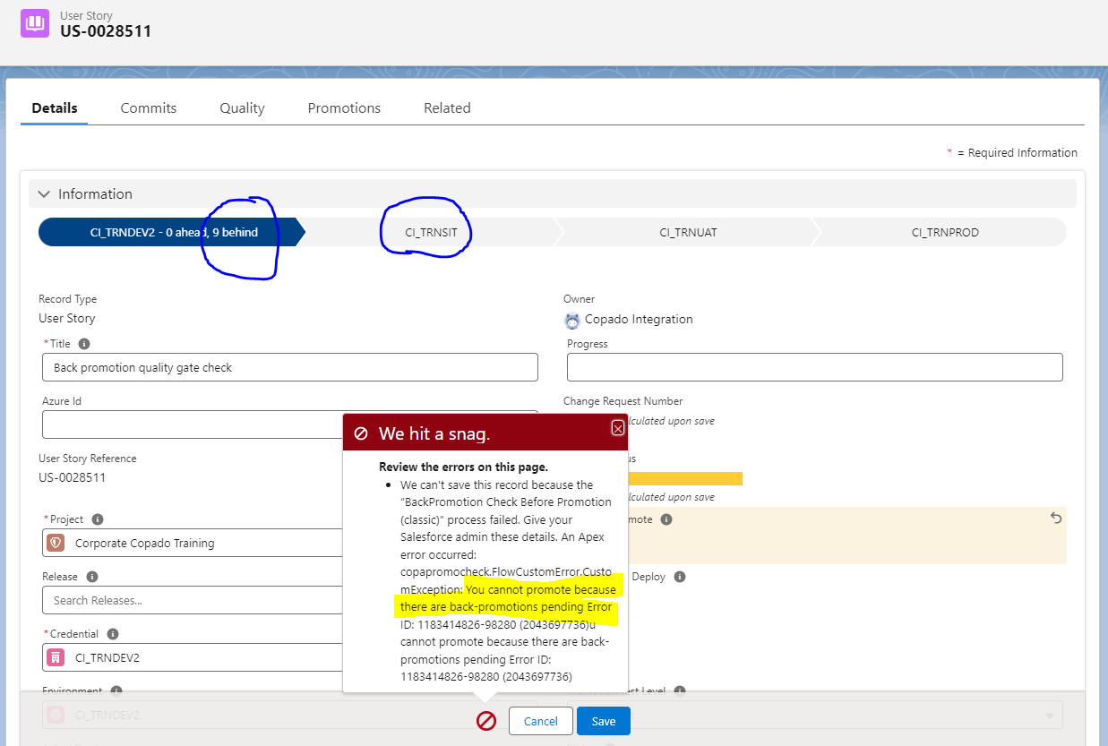
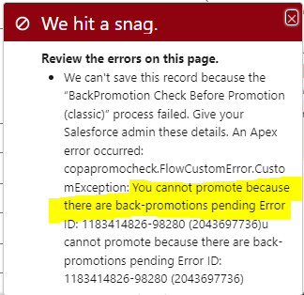

Steps to follow before we enable the Quality gate:

- Reach out to E3 Copado team to include/exclude pipelines/envs for the quality gate check with justification.
- Provide us the info to keep the back promotions in a respective environment, so E3 copado team can create new custom conditions accordingly.
- We setup the count for number of Back promotions to “10”. If your pending back promotions exceed this count, you will be unable to promote a User Story to next environment untill you clear the pending back promotions.
- Keep environments in sync to avoid environment/branch refresh.

